1D Sedimentation of a sphere

1. **Introduction**

In this work, we simulate the sedimentation of a single sphere using the sedFoam multiphase solver in OpenFOAM. The setup uses overset meshes and six-degree-of-freedom (6DoF) dynamics to fully resolve motion without mesh distortion, enabling clean particle descent and interaction with the fluid.

1. **Objective**

To replicate and validate the experimental findings of ten Cate et al. (2002) regarding the settling of a sphere in a viscous fluid using high-fidelity CFD tools, and to analyze the fluid-particle interactions under gravity using dynamic mesh and multiphase Modeling. [(Settling Sphere by Michael Alletto).](https://wiki.openfoam.com/Settling_Sphere_by_Michael_Alletto)

1. **Simulation Setup**
   1. **Geometry:**
   * The computational domain consists of a static **background mesh** and a moving **overset mesh** enclosing the sphere.
   * Background mesh size: **cube of length ~133.3 mm**
   * Overset mesh: smaller cube moving with the sphere.

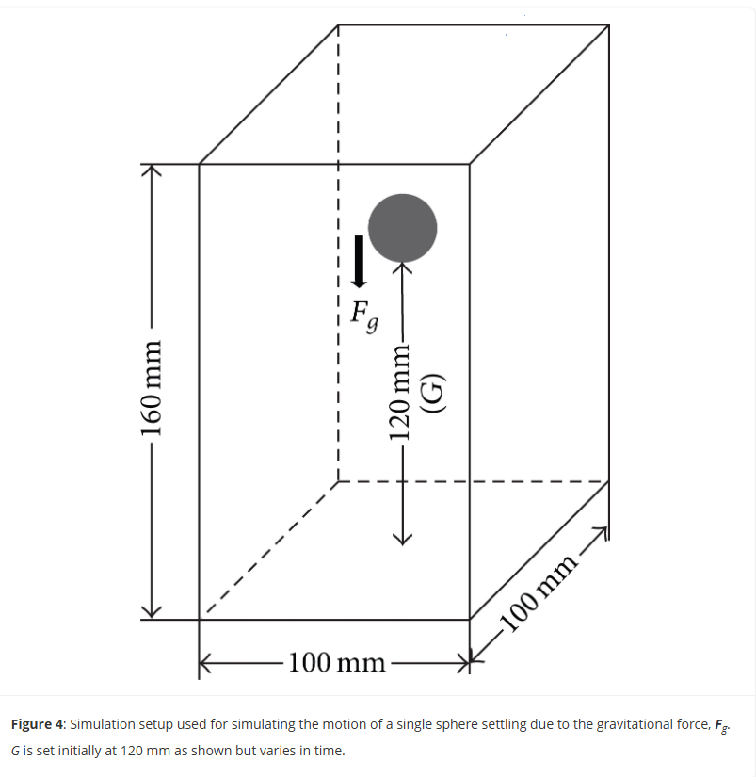

Figure 1:Simulation geometry setup used for simulating the single sphere settling due to the gravitational force

* 1. **Domain Dimensions**
* A 3D box: **100 mm x 100 mm x 160 mm**
* Sphere diameter: **15 mm (0.015 m)**
  1. **Initial Condition**
* The sphere is initially located at **120 mm height** in the domain.
* Fluid is at rest.
  1. **Meshing:**
  + blockMesh + snappyHexMesh used to define sphere and background domains.
  + transformPoints used to scale geometry to physical size.
  + topoSet assigns zone IDs (0 for background, 1 for overset).
  1. **Physics:**
  + **Solver used:** overSedDymFoam_rbgh (includes 6DoF motion).
  + **Motion model:** sixDoFRigidBodyMotionSedFoam
  + The sphere's motion is governed by the balance of buoyancy and drag, with gravity acting downward.
  + The simulation tracks free fall from rest to near-wall interaction.

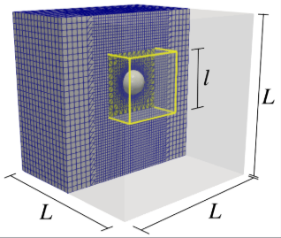

Figure 2: Geometrical domain for the falling sphere using an overset mesh

1. **Solver and Physics Model**
   1. **sedFoam Overview**

sedFoam is a two-phase, Eulerian-Eulerian solver based on OpenFOAM. It supports multiphase, turbulent, and particle-laden flows. Key features include:

* Multiphase momentum coupling
* Granular rheology
* Dynamic mesh motion (overset, rigidBody)
  1. **SixDoFRigidBodyMotion**

This library enables rigid body motion with six degrees of freedom. It updates the particle’s position and orientation based on hydrodynamic forces, gravity, and collisions.

In this case:

* The **sphere** is governed by sixDoF motion
* Mass and inertia tensors are defined in constant/dynamicMeshDict
* The movement is solved implicitly and coupled with the flow field
  1. **Overset Mesh (Chimera Grid)**

Overset meshes allow moving bodies (like the sphere) to have a separate, finely resolved mesh that moves over a static background mesh. Benefits:

* Avoids mesh distortion
* Allows large translations and rotations
* Ensures accurate interface interpolation

Files:

* constant/oversetMesh defines donor and receiver zones
* constant/dynamicMeshDict handles interpolation and motion strategy

1. **Simulation Setup**
   1. **Domain and Mesh**

* **Domain**: Rectangular tank, background mesh
* **Sphere**: Separate mesh (refined), embedded using overset
* **Mesh Creation**:
  + blockMesh creates the tank mesh
  + snappyHexMesh is used for sphere (as per sphereMesh dir)
  + mergeMeshes and createPatch used to combine and prepare overset interpolation
  1. **Mesh Statistics and Grid Size**
* **Total cells (Grid Size)**: 70,472
* **Cell types**:
  + Hexahedra: 53,656
  + prisms: 312
  + Polyhedra: 16,504
* **Point count**: 86,083
* **Regions**: 2 (background + sphere)
* **Patches**: 7 (including overset and sphere surface)
  1. **Initial and Boundary Conditions**
* Velocity U: Initially zero
* Pressure p_rgh: Hydrostatic equilibrium
* Phase fraction alpha: Defined for both fluid and solid
* Gravity vector defined in constant/g
  1. **Material Properties (constant/transportProperties)**
* Two-phase system: fluid (silicon oil analog) and solid.
* Fluid viscosity and density match experimental values:
  + Viscosity: Case dependent (e.g. 373 mPa·s for Re ≈ 1.5)
  + Density: 970–960 kg/m³ for fluid, 1120 kg/m³ for sphere
  1. **Time Control and Numerical Schemes**
* Time stepping: Fixed (small dt (1E-05) to capture transients).
* Schemes: Upwind for convection, central differencing for diffusion.

1. **Results and Validation**
   1. **Trajectory and Velocity**

* The simulation tracks sphere position using xcenter.txt, zcenter.txt, etc.
* Velocity data in vx.txt, vy.txt, vz.txt
* The sphere accelerates under gravity, reaches terminal velocity, and decelerates near the bottom.
  1. **Simulation Time:**

The complete simulation took 82236 sec (approx. 23 hrs).

* 1. **Comparison with Reference Data**

**Experimental Reference**:  
ten Cate et al. measured the trajectory and fluid field using PIV for Re = 1.5

**Simulation Images**:

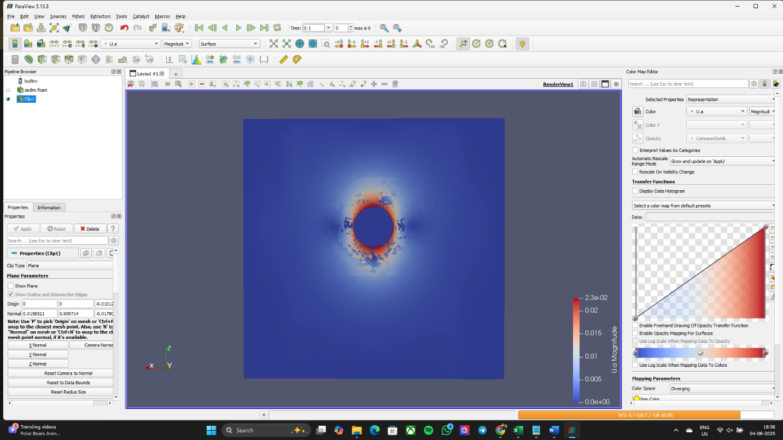

Figure 3: Initial position of the sphere and the fluid interaction

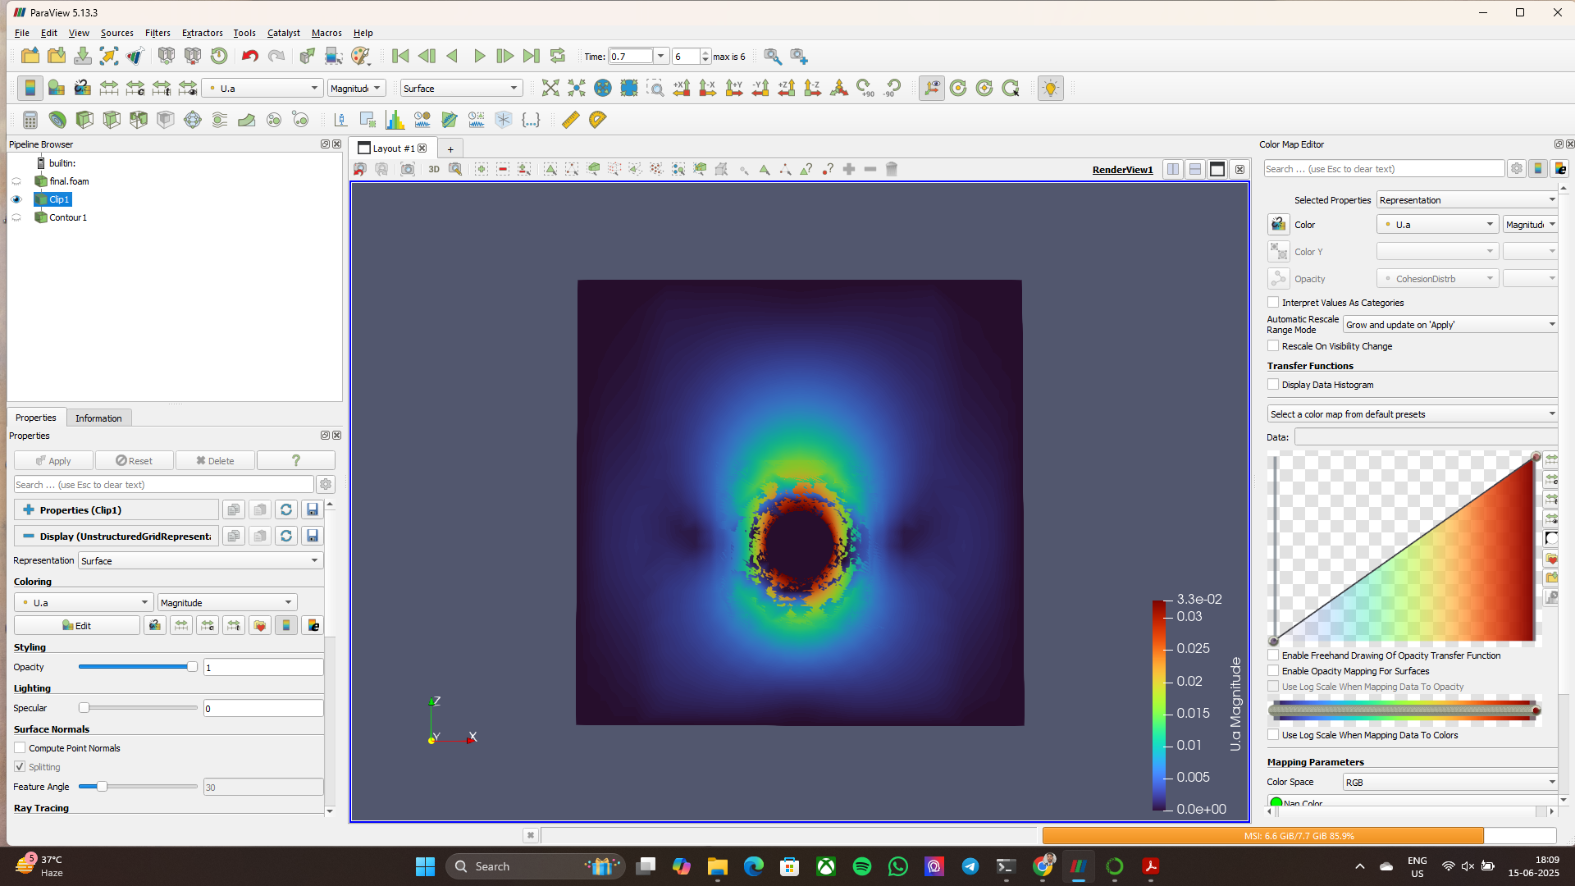

Figure 4: Final position of the sphere and the fluid interaction

**Contour Plot (Flow Field) generated by the Sphere during sedimentation at Re 1.5:**

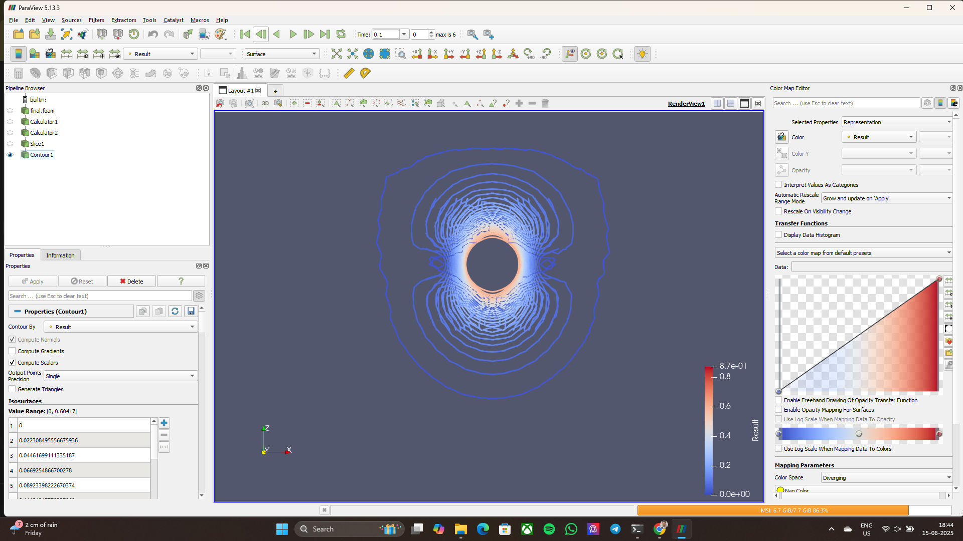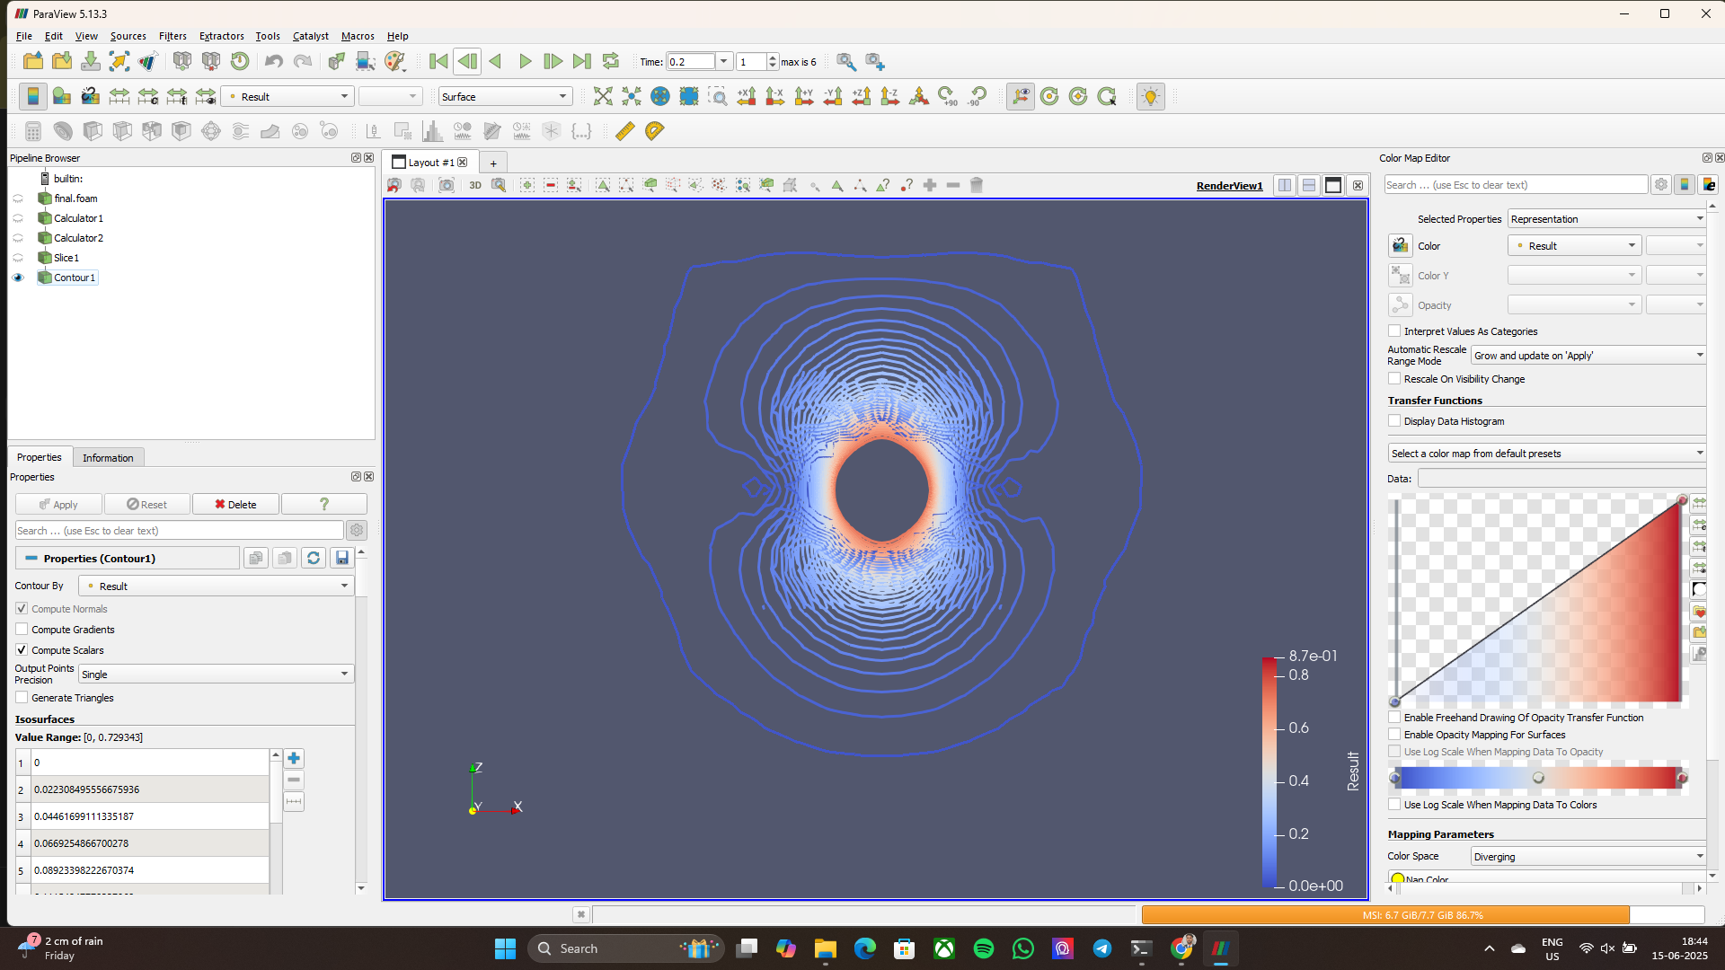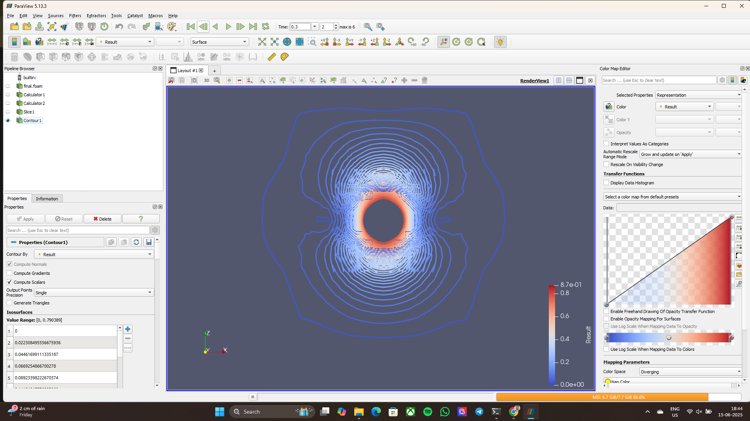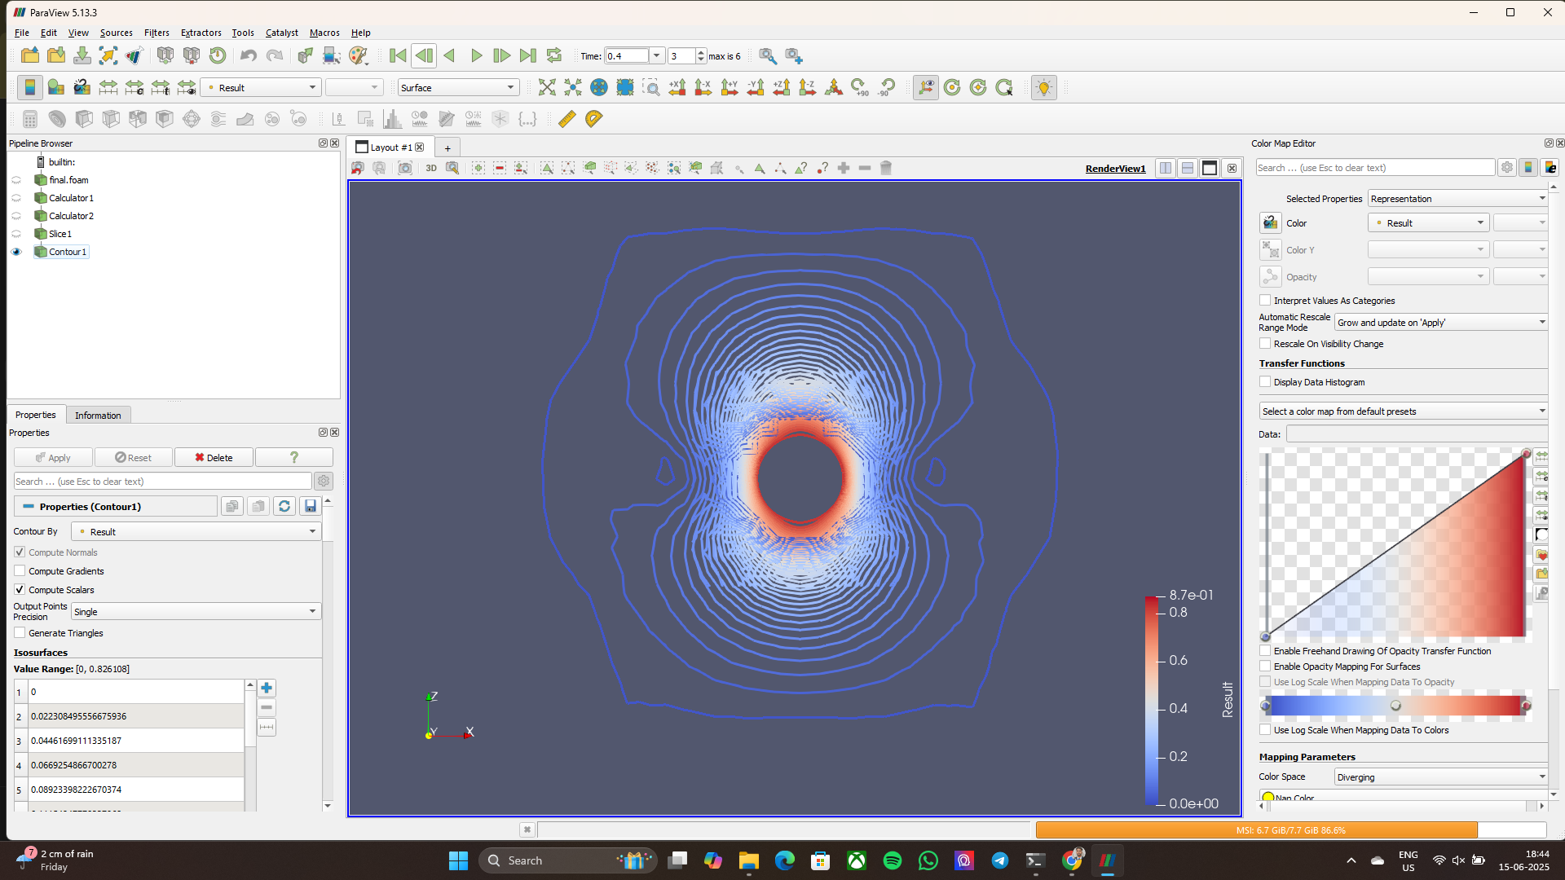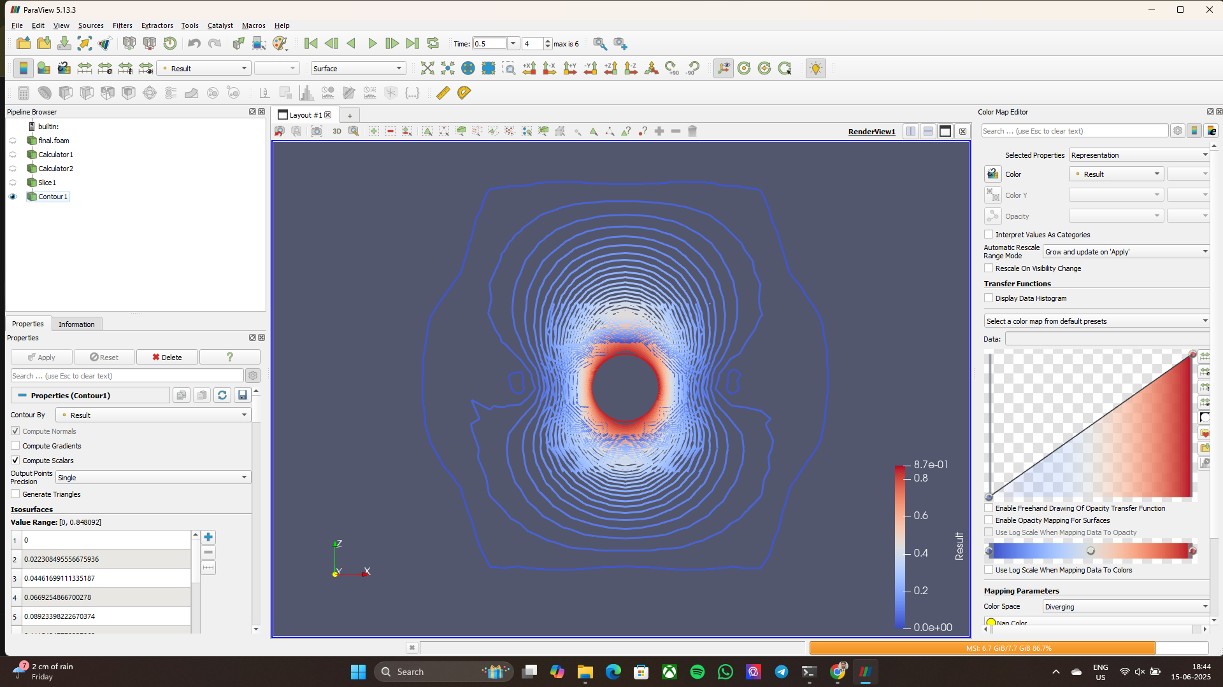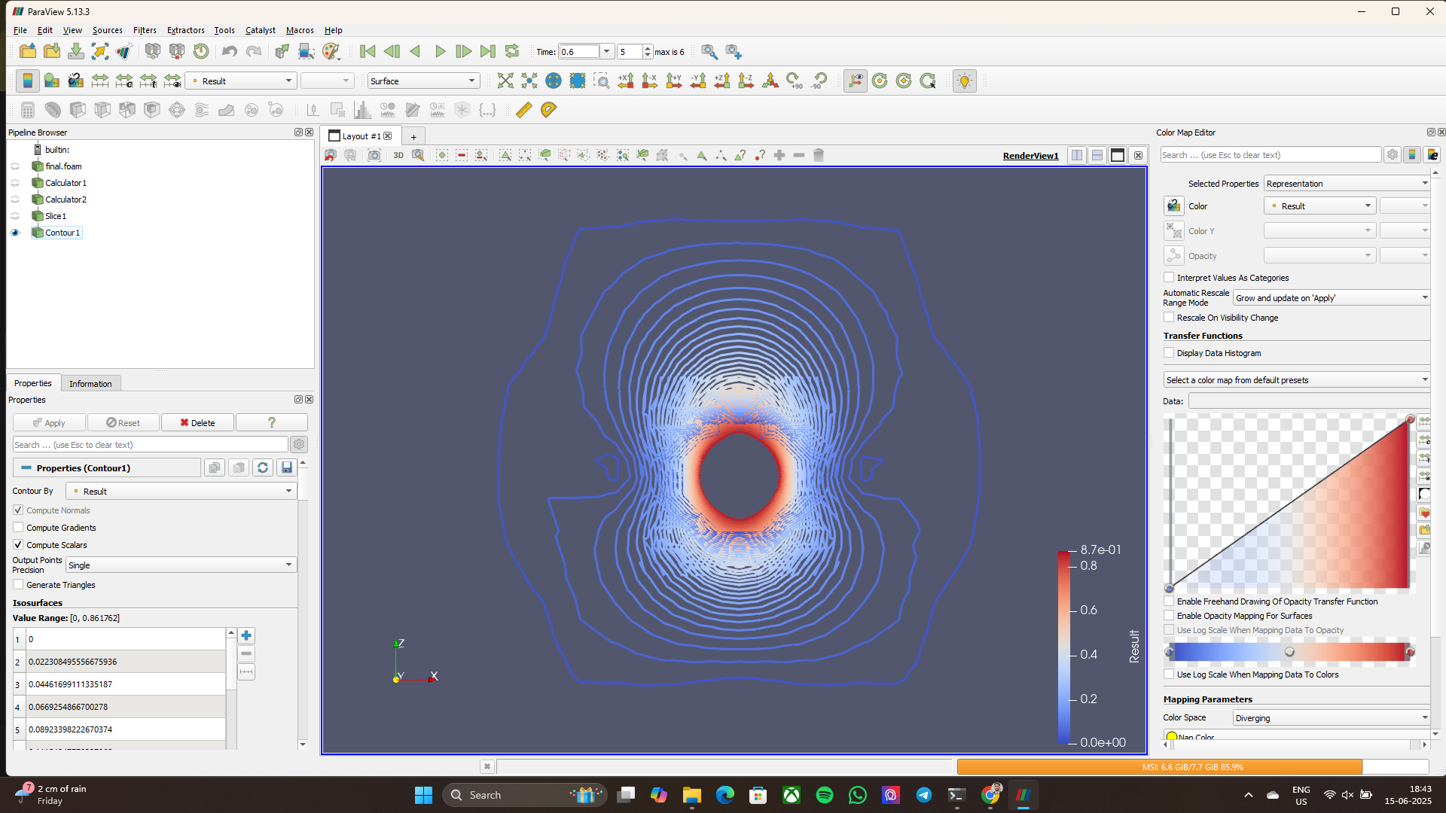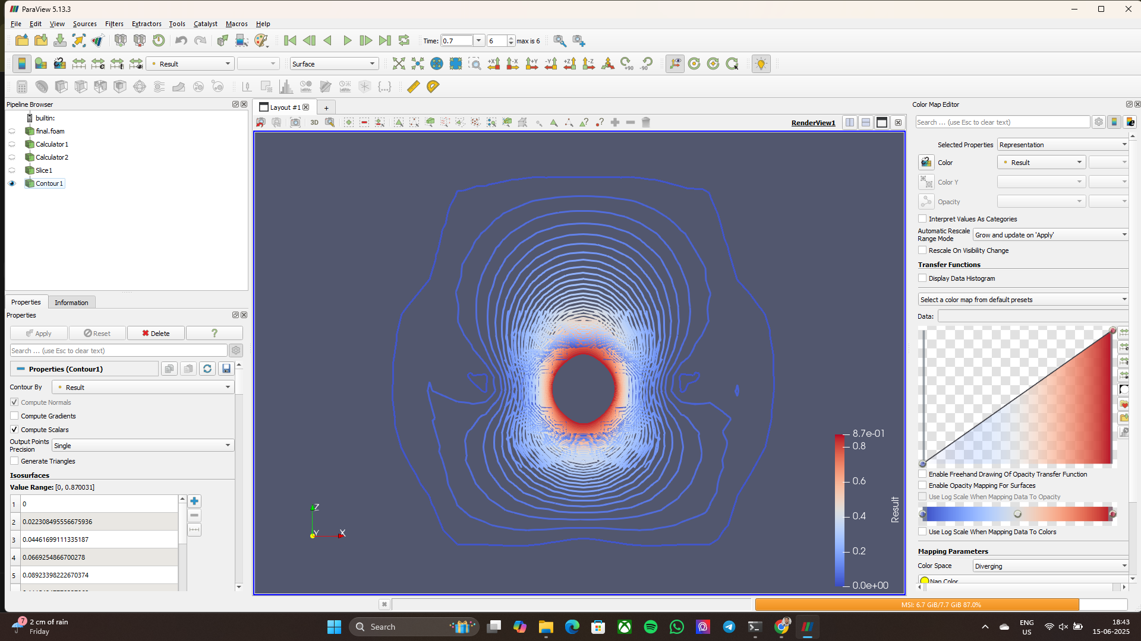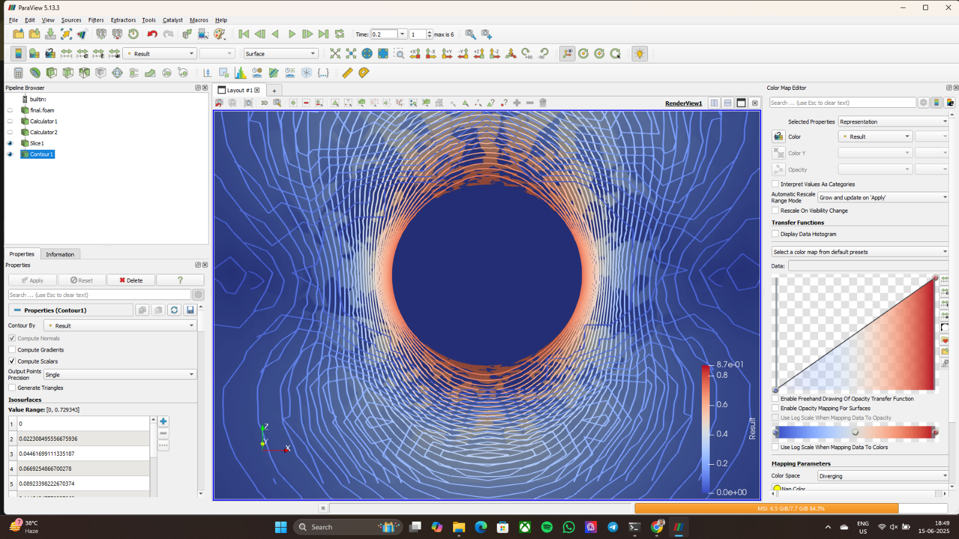

Figure 6: Contours generated by the sphere at tie instance 0.2 sec

Figure 5: Contours generated by the sphere at tie instance 0.1 sec

Figure 7: Contours generated by the sphere at tie instance 0.3 sec

Figure 8: Contours generated by the sphere at tie instance 0.4 sec

Figure 9: Contours generated by the sphere at tie instance 0.5 sec

Figure 10: Contours generated by the sphere at tie instance 0.6 sec

Figure 11: Contours generated by the sphere at tie instance 0.7 sec

Figure 12: Zoomed in at the contour plot focused at the sphere center

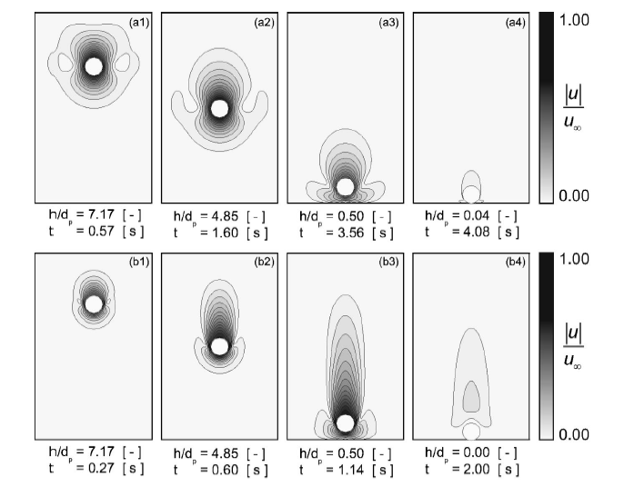

Figure 13: Contour from the reference Paper for comparison at Re 1.5

* Show clear vortex formation and wake at higher Reynolds numbers.
* Contour plots (e.g., FallingSphereComparison.png) align closely with the experimental velocity fields and wake patterns.
* Sphere settles with **no rebound**, as expected at low Stokes numbers (St < 10).

**Quantitative Comparison**:

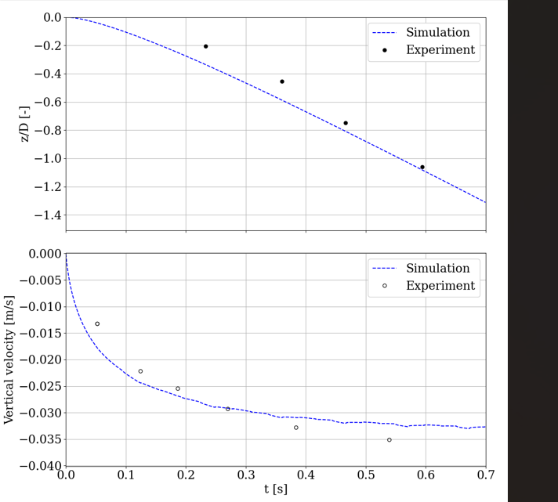

Figure 14: Sphere a) trajectory and b) velocity evolution using an overset mesh till time instance 0.7 sec.

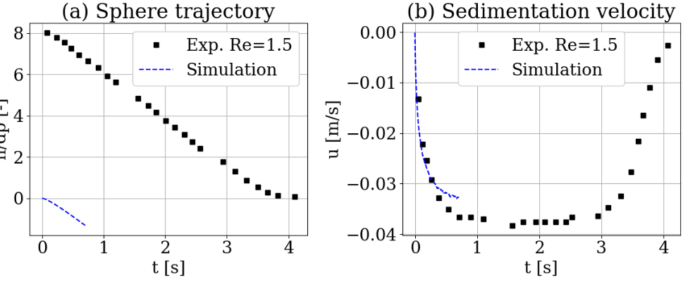

Figure 15: Sphere velocity evolution using an overset mesh for whole sedimentation in experimental and till 0.7-time instance in simulation.

* 1. **Observations**
* The **sphere starts from rest** (Vz​=0) and accelerates due to gravity.
* **Velocity increases rapidly at first** but quickly reaches a plateau around −0.028m/s, suggesting the approach to terminal velocity.
* The **position curve (z/D)** is smooth and convex, typical of a body accelerating and then entering a steady-fall regime.
* The simulation shows **no significant rebound or oscillation**, consistent with expectations at Reynolds number ≈ 1.5 (as in ten Cate et al., 2002).
* Steady-state appears to be reached around **0.5 seconds**, after which velocity stabilizes, validating the dynamic mesh and 6DoF setup.

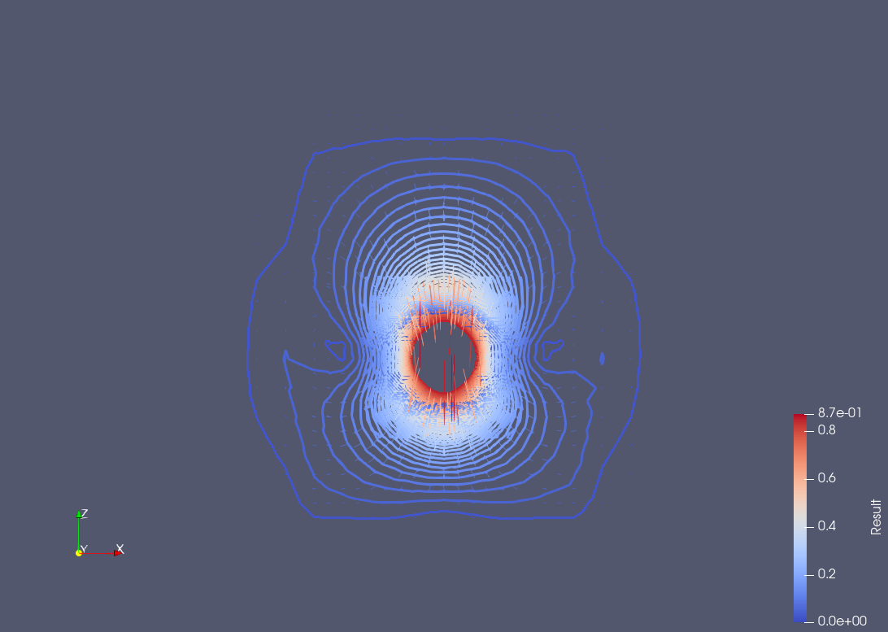

Figure 16: flow field of the sphere at a dimensionless gap height of z/*d = 1.2*

1. **Discussion**
   1. **Accuracy and Robustness**

* Overset mesh ensures smooth descent without remeshing
* sixDoF library realistically captures inertia and torque
* Minor discrepancies near bottom approach due to unmodeled lubrication forces (can be added analytically)
* **Errors:**
* Velocity (Vz): Mean % Error = 14.12%, Max % Error = 34.32%
* Simulated z/D at given times:
* Time: 0.084430391 s -> Sim z/D: -0.08324
* Time: 0.232789799 s -> Sim z/D: -0.33577 Error = 62.81%
* Time: 0.360096720 s -> Sim z/D: -0.58736 Error = 28.93%
* Time: 0.466406266 s -> Sim z/D: -0.80865 Error = 8.2%
* Time: 0.593878521 s -> Sim z/D: -1.08151 Error = 2.1%
* Time: 0.742403263 s -> Sim z/D: -1.40435 Error = 4.04%
  1. **Numerical Challenges**
* Interpolation across overset interfaces can introduce errors
* Small time steps required to maintain coupling stability
* Solver settings need fine-tuning for low Re cases

1. **Conclusion**

This study successfully reproduces the classic sedimentation benchmark using modern CFD tools:

* The sedFoam solver with sixDoF motion and overset mesh accurately captures the full sedimentation dynamics.
* Comparisons with experimental data from ten Cate et al. validate the physical and numerical Modeling.
* This approach is extensible to multiple particles and turbulent flows with minimal modifications.